Test accounts
- Admin A1: active admin, valid credentials

Fleet and route data
- Bus B1: active, assigned to Route R1
- Bus B2: active, unassigned
- Bus B3: inactive or under-maintenance
- Route R1: valid route with stations
- Route R2: valid route
- Route R3: valid route with no active buses, for schedule failure testing

Ticket data
- T1: active valid ticket for P1 on R1
- T2: expired ticket
- T3: already used ticket
- T4: checked-in ticket awaiting checkout
- T5: guest ticket if your app supports it

3. Smoke test suite
Run these first every time before detailed testing.
Test ID | Scenario | Steps | Expected Result
SMK-01 | App launch | Start MetroManage | Application opens without crash
SMK-02 | DB connectivity | Open login and try a valid login | System responds normally and does not show DB/system failure
SMK-03 | Admin dashboard access | Login as active admin | Dashboard opens
SMK-04 | Core navigation | Open Users, Fleet, Allocation, Ticketing, Reports screens | Each module opens without crash
SMK-05 | Basic data load | Open tables in Users and Fleet | Existing data loads in UI
SMK-06 | Logout/close flow | End session and reopen app | App returns to valid initial state

Evidence to capture
- app launch screenshot
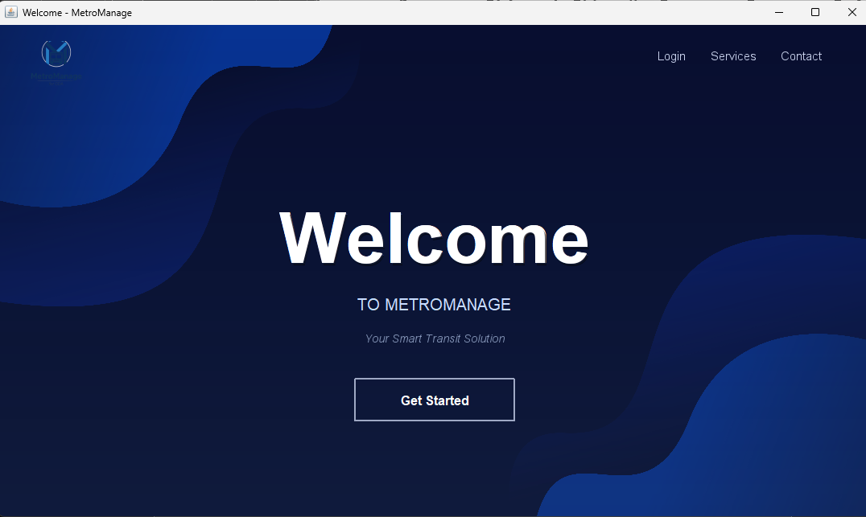
- dashboard screenshot
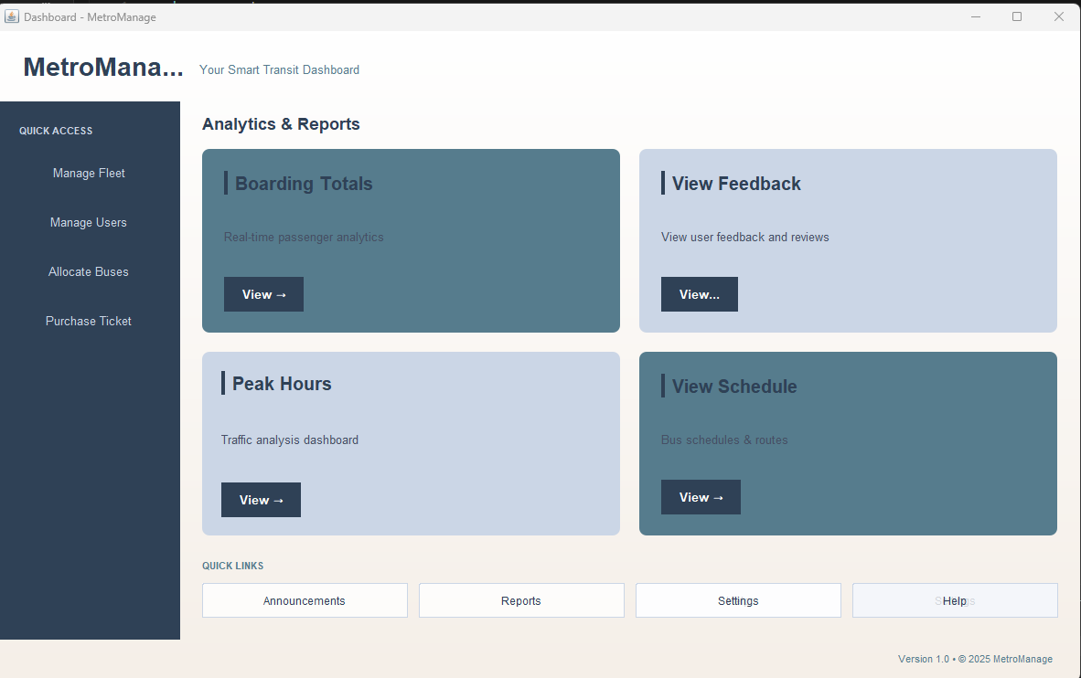
- one screenshot of each main module opening
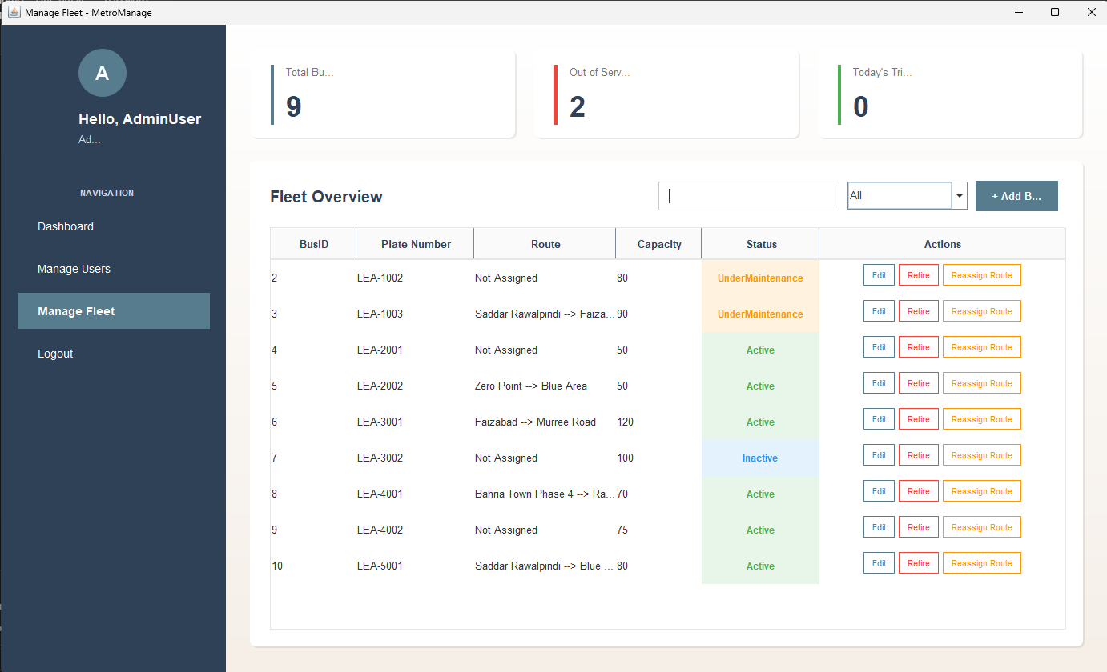
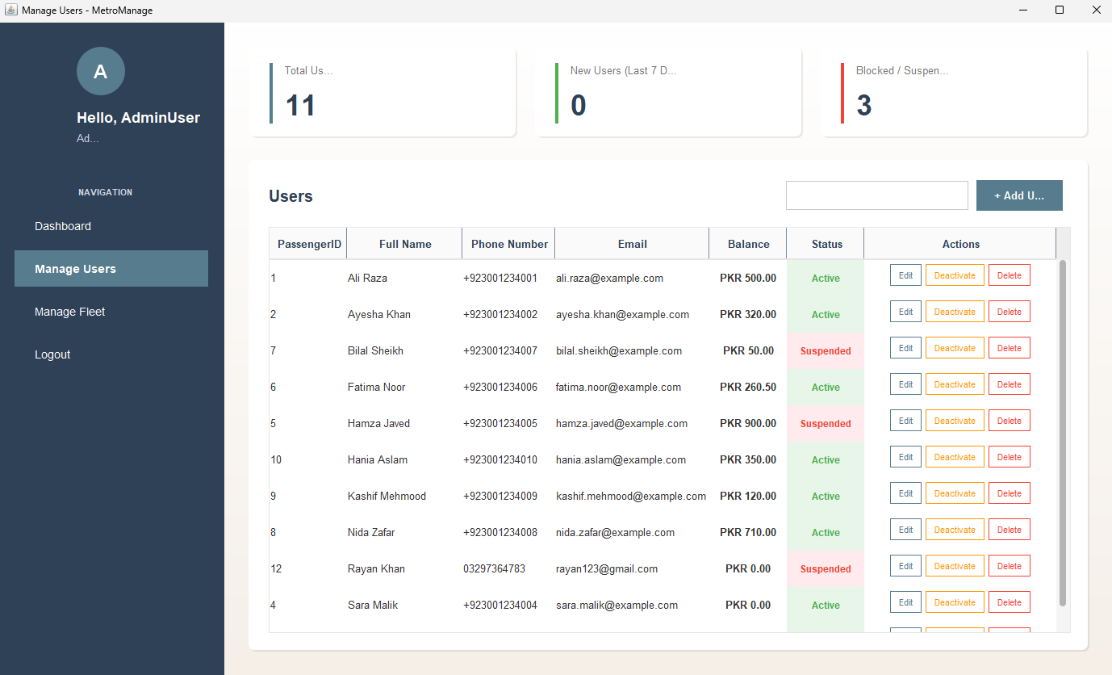
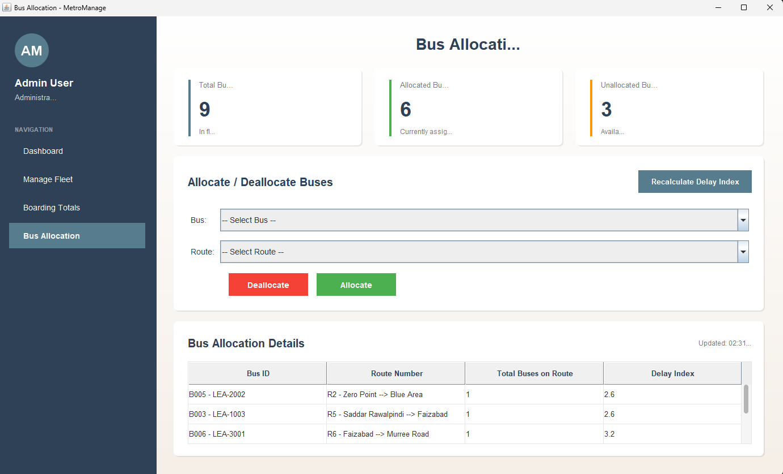
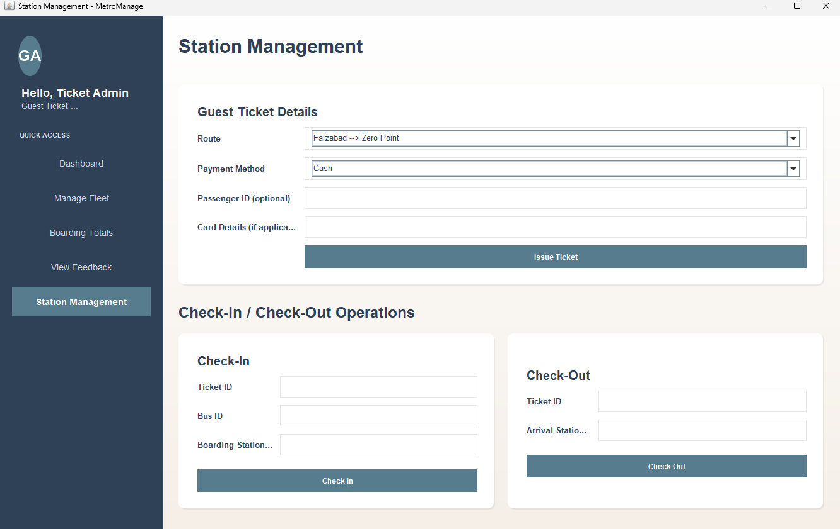
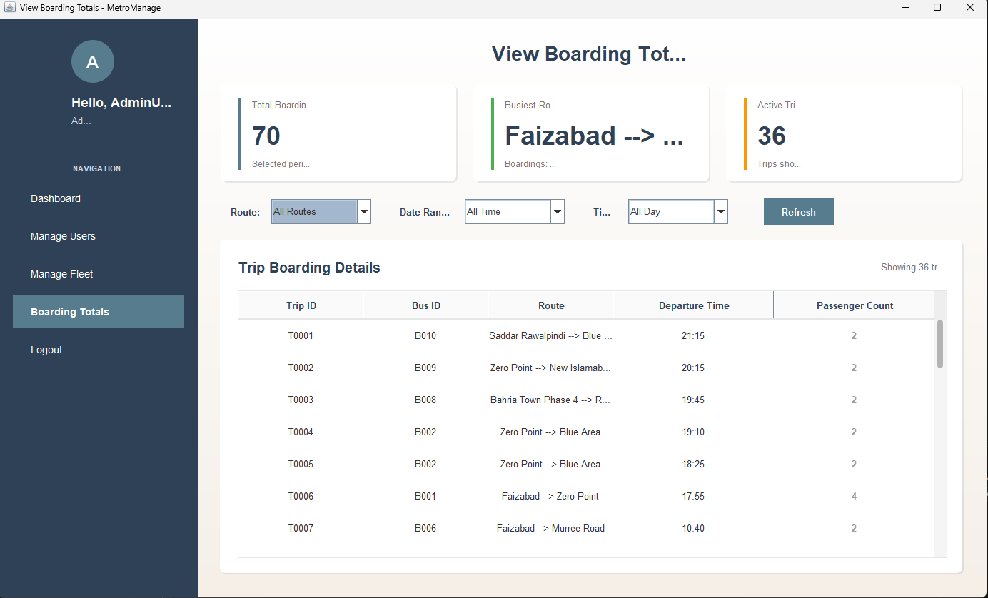
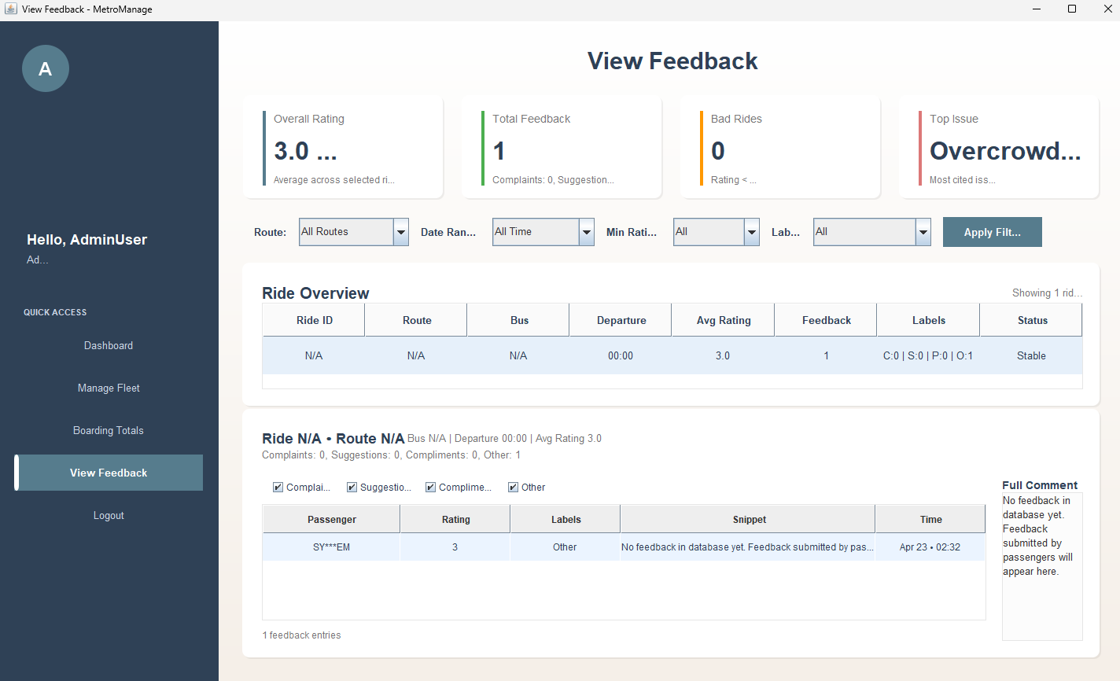
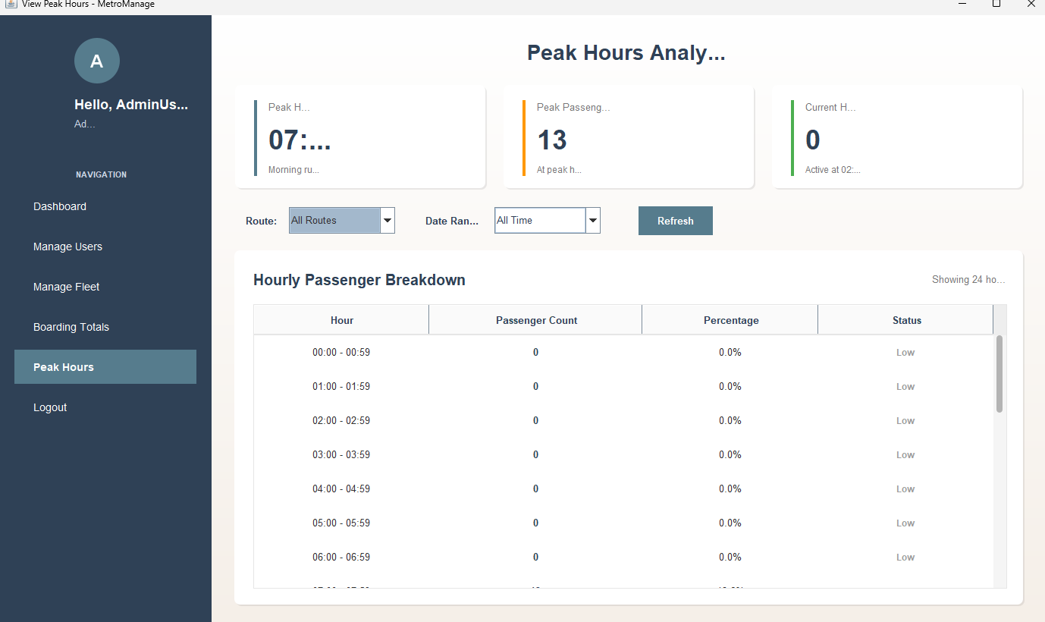
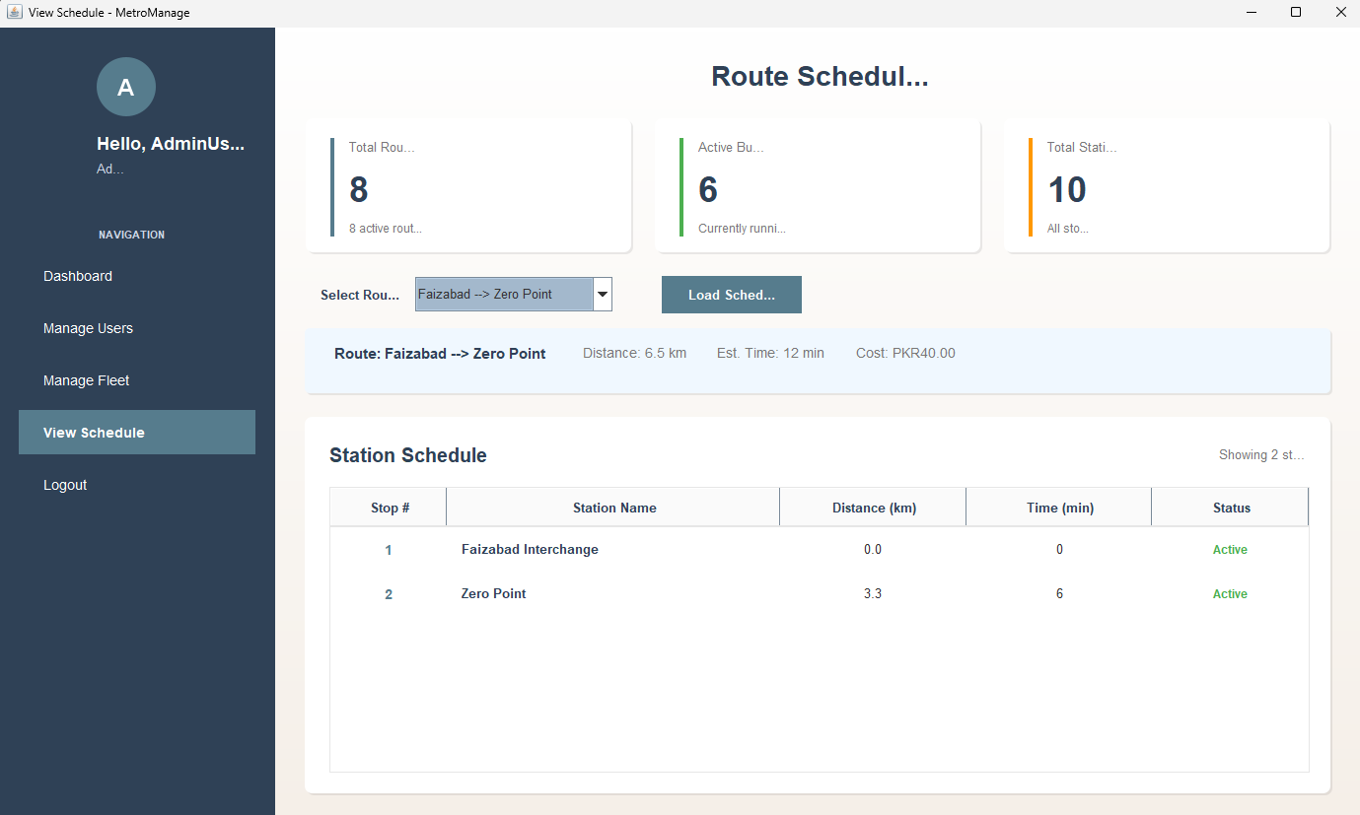
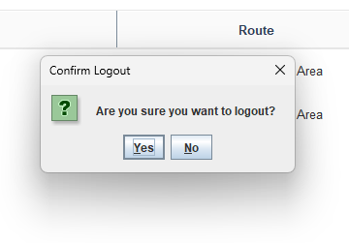

4. Black-box test cases

4.1 UC06 Login
The report says login should authenticate a valid passenger, reject invalid credentials, handle locked/unavailable conditions, and the system also uses admin authentication for the main desktop console. Security requirements also say only authenticated admins may access the main desktop application.
Test ID | Technique | Scenario | Steps | Expected Result
BB-LOG-01 | Equivalence Partitioning | Valid active admin login | Enter valid active admin email and correct password | Login succeeds and dashboard opens
BB-LOG-02 | Equivalence Partitioning | Invalid email | Enter non-existent admin email and any password | Login rejected with invalid account message
BB-LOG-03 | Equivalence Partitioning | Wrong password | Enter valid admin email and wrong password | Login rejected with incorrect password
BB-LOG-04 | Error Guessing | Inactive admin login | Enter inactive admin email and correct password | Login should be blocked
BB-LOG-05 | Error Guessing | Empty credentials | Leave login fields blank and submit | Validation or login rejection; no dashboard access

Immediate evidence
- screenshot of successful login
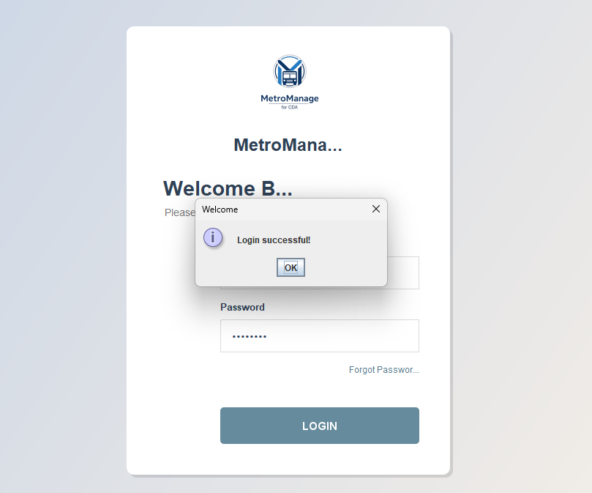
- screenshot of invalid email failure
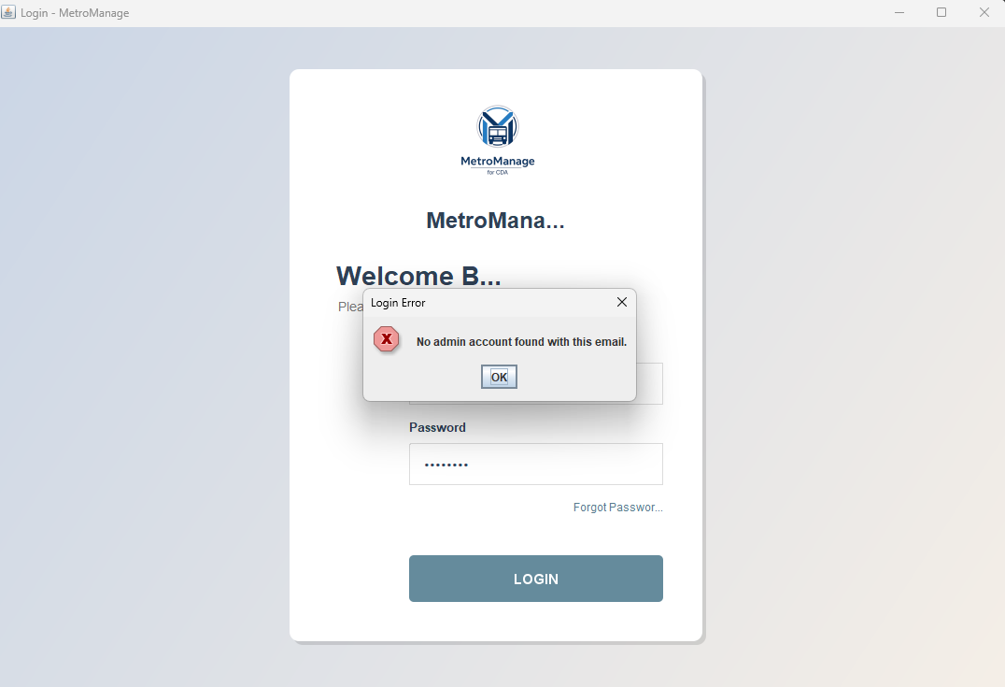
- screenshot of wrong password failure
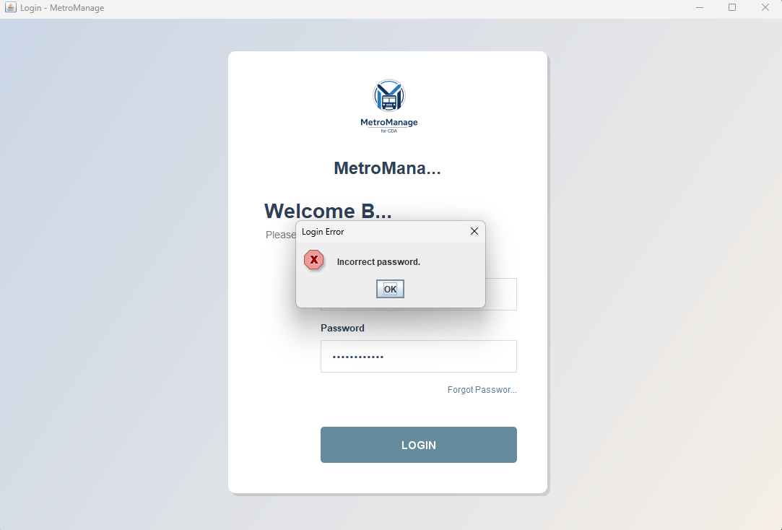

DB check
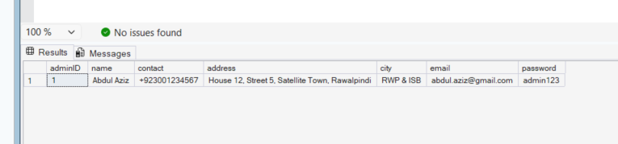

4.2 UC01 Manage User Accounts
The report defines create, update, search, deactivate, and duplicate/validation handling for user accounts. It also says user actions should persist state and record controlled account management behavior.
Test ID | Technique | Scenario | Steps | Expected Result
BB-USR-01 | Equivalence Partitioning | Add valid passenger | Open Users, add user with valid name, phone, email, password | User created successfully
BB-USR-02 | Error Guessing | Add duplicate email | Add another user with an existing email | User creation blocked
BB-USR-03 | Error Guessing | Missing fields | Leave full name / phone / email blank and submit | Validation message shown; no user added
BB-USR-04 | Error Guessing | Invalid email format | Enter malformed email and submit | Validation error shown
BB-USR-05 | Equivalence Partitioning | Edit existing passenger | Open edit on existing user, update name/phone/status | Updated values saved and shown
BB-USR-06 | Equivalence Partitioning | Search by name | Search an existing passenger name | Matching row(s) shown
BB-USR-07 | Equivalence Partitioning | Search by email | Search an existing email | Matching row(s) shown
BB-USR-08 | Business Rule | Toggle active/inactive status | Change status of active user to inactive | Status updates correctly
BB-USR-09 | Error Guessing | Delete user | Delete a user from Users module | User removed from active list / soft delete behavior reflected
BB-USR-10 | Negative | Edit deleted/nonexistent user | Try edit action on missing user if reproducible | System handles safely without crash

Evidence
- add-user dialog screenshot
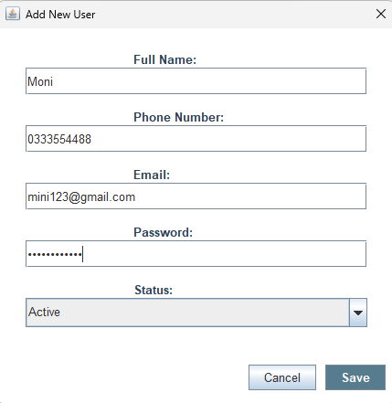
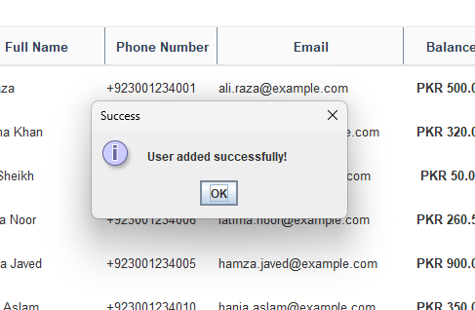

- validation failure screenshot
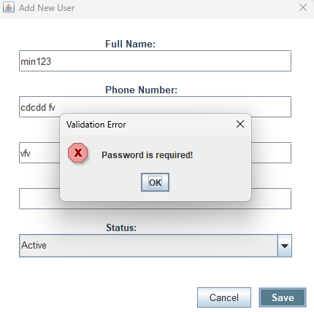
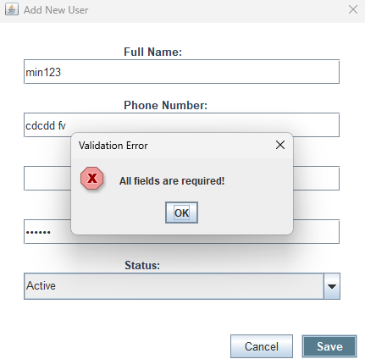

- duplicate-email failure screenshot
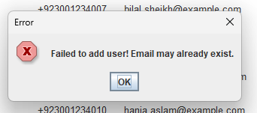
- after edit screenshot
- search result screenshot
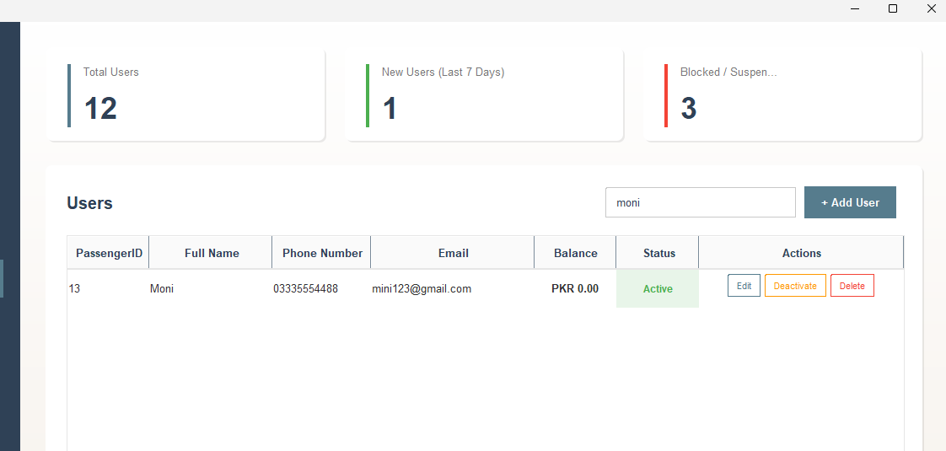
- delete/status change screenshot
- 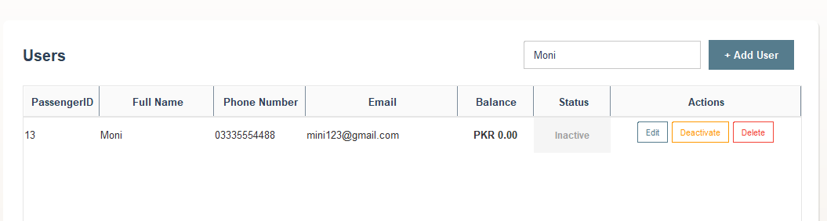
- 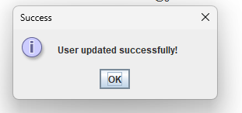

DB verification
- verify passenger row inserted/updated/deactivated/deleted state in DB

4.3 UC02 Manage Bus Fleet
The report says fleet management includes add, edit, status changes, search, and preserving bus history. It also states only valid fleet data should be allowed and retired buses must not be assignable.
Test ID | Technique | Scenario | Steps | Expected Result
BB-FLT-01 | Equivalence Partitioning | Add valid bus | Add bus with valid plate, positive capacity, valid status, route | Bus is created
BB-FLT-02 | Boundary Value | Capacity at valid minimum | Add bus with smallest acceptable positive capacity | Bus accepted
BB-FLT-03 | Boundary Value | Capacity zero | Add bus with capacity 0 | Validation blocks save
BB-FLT-04 | Boundary Value | Negative capacity | Add bus with negative capacity | Validation blocks save
BB-FLT-05 | Error Guessing | Non-numeric capacity | Enter letters in capacity field | Validation error shown
BB-FLT-06 | Equivalence Partitioning | Edit bus | Update bus route/status/capacity | Bus changes saved
BB-FLT-07 | Equivalence Partitioning | Search by plate | Search a known plate number | Matching bus appears
BB-FLT-08 | Equivalence Partitioning | Filter by status | Select a status filter | Only matching buses appear
BB-FLT-09 | Business Rule | Retire/delete bus | Retire an existing bus | Bus removed from active operational pool
BB-FLT-10 | Business Rule | Retired/inactive bus later used in allocation | After retiring/inactivating bus, try allocating it | System should block allocation or prevent it from valid active pool

Evidence
- add bus success screenshot
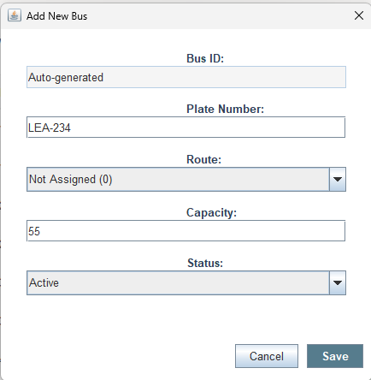
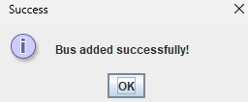
- capacity validation screenshot
- search/filter screenshot
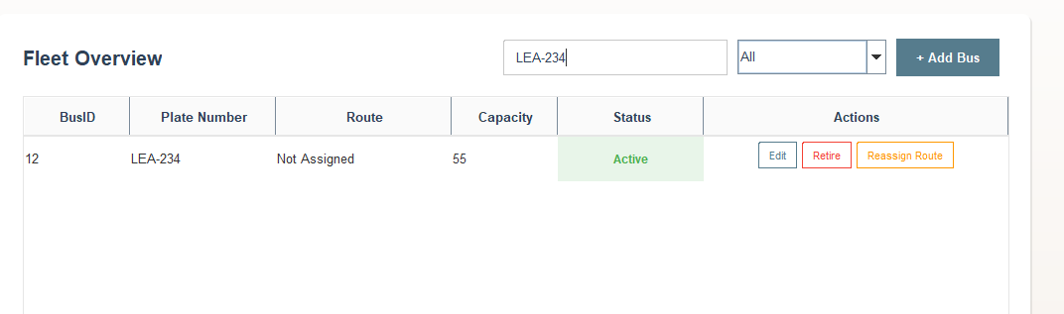
- retired bus screenshot
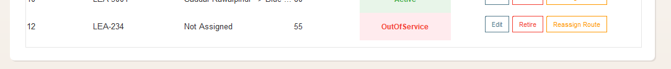
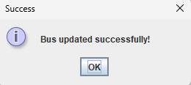

DB verification
- verify bus record inserted/updated/soft-deleted or status-changed
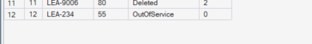

4.4 UC03 Allocate Buses to Routes and UC04 Reallocate Buses
The report defines bus allocation and reallocation based on route availability, active status, and operational constraints, with policy violation and insufficient active bus extensions.
Test ID | Technique | Scenario | Steps | Expected Result
BB-ALC-01 | Equivalence Partitioning | Allocate free active bus to valid route | Choose route and free active bus, submit allocation | Allocation succeeds
BB-ALC-02 | Error Guessing | No route selected | Submit allocation without selecting a route | Validation error shown
BB-ALC-03 | Error Guessing | No bus selected | Submit allocation without selecting a bus | Validation error shown
BB-ALC-04 | Business Rule | Reallocate already assigned bus | Select a bus already assigned elsewhere and allocate to another route | Confirmation shown, then allocation updated if accepted
BB-ALC-05 | Business Rule | Deallocate assigned bus | Select allocated bus and deallocate | Route assignment removed
BB-ALC-06 | Error Guessing | Deallocate unassigned bus | Select bus not assigned to any route and deallocate | Error message shown
BB-ALC-07 | Business Rule | Allocate inactive/maintenance bus | Try selecting invalid-state bus for allocation if available in UI | Allocation should not proceed
BB-ALC-08 | Business Rule | Reallocation causing operational inconsistency | Attempt suspicious reallocation scenario | System should handle gracefully and not crash

Evidence
- allocation success screenshot
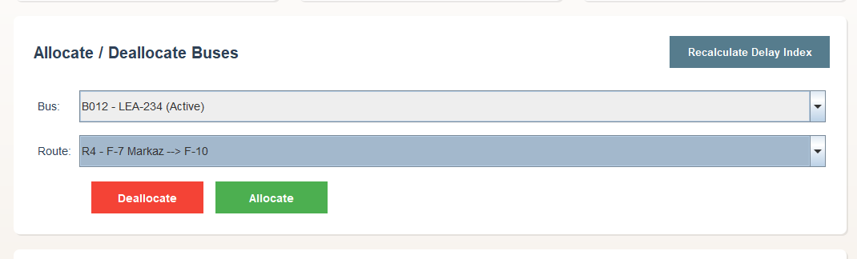
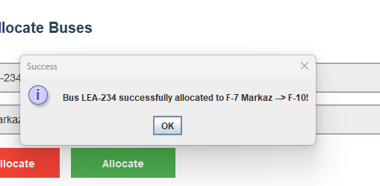
- reallocation confirmation screenshot
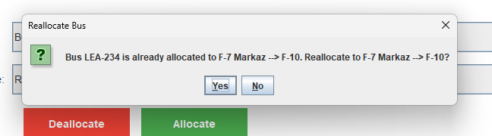
- deallocation screenshot
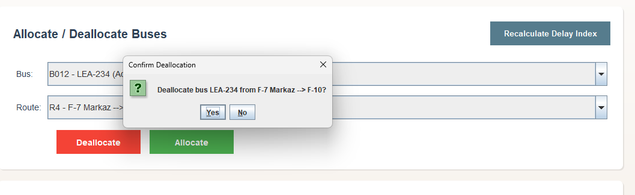
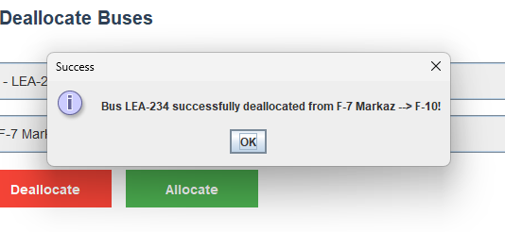
- validation error screenshot

DB verification

- verify bus routeID changed after allocation/reallocation
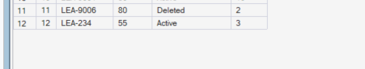
- verify routeID reset or updated after deallocation
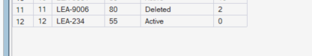

4.5 UC07 Purchase Ticket
The report says ticket purchase must calculate fare, process payment, generate a ticket/QR, record transaction, and reject invalid route/payment states. It also mentions payment failure and ticket-generation failure scenarios.
Test ID | Technique | Scenario | Steps | Expected Result
BB-TKT-01 | Equivalence Partitioning | Issue guest ticket with cash | Select valid route, payment method Cash, no passenger ID, submit | Ticket issued successfully
BB-TKT-02 | Equivalence Partitioning | Issue ticket for registered passenger with wallet | Select valid route, payment Wallet, enter valid passenger ID with enough balance | Ticket issued and wallet reduced
BB-TKT-03 | Error Guessing | Wallet payment without passenger ID | Select Wallet and leave passenger ID blank | Validation error shown
BB-TKT-04 | Error Guessing | Invalid passenger ID format | Enter non-numeric passenger ID | Validation error shown
BB-TKT-05 | Error Guessing | Passenger ID not found | Enter numeric but non-existent passenger ID | Validation warning shown
BB-TKT-06 | Error Guessing | Card payment without card details | Select Card and leave card details blank | Validation error shown
BB-TKT-07 | Error Guessing | Card details wrong format | Enter card details without required commas | Validation error shown
BB-TKT-08 | Equivalence Partitioning | Card payment valid format | Enter valid route + Card + correctly formatted card details | Ticket issued successfully
BB-TKT-09 | Business Rule | Wallet with insufficient balance | Use low-balance passenger with Wallet payment | Ticket should not be issued
BB-TKT-10 | Error Guessing | No route selected | Submit without valid route selection | Validation blocks ticket issue
BB-TKT-11 | Negative | Unsupported payment path | Try edge flow that results in invalid payment setup | Graceful error, no crash

Evidence

- generated ticket ID screenshot
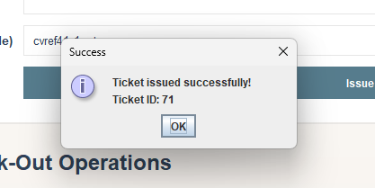
- invalid card format screenshot
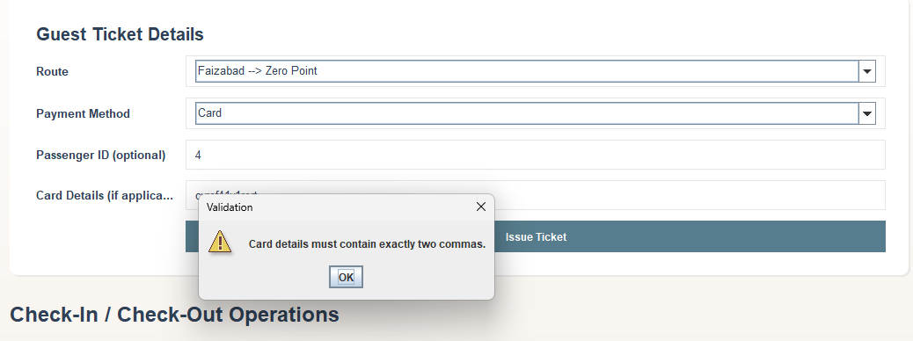

DB verification
For BB-TKT-01, 02, 08:
- verify new ticket record
- verify payment record
- verify ride record created
- verify passenger wallet deduction for wallet payment

4.6 UC08 Check-In
The report requires check-in to validate QR/ticket status, ensure ticket is valid and unused, then log boarding and allow boarding. It also says invalid/already-used tickets must be denied.
Test ID | Technique | Scenario | Steps | Expected Result
BB-CIN-01 | Equivalence Partitioning | Valid check-in | Enter valid active ticket ID, valid bus ID on correct route, valid boarding station ID | Check-in succeeds
BB-CIN-02 | Error Guessing | Missing fields | Leave ticket/bus/station field blank | Validation error shown
BB-CIN-03 | Error Guessing | Non-numeric IDs | Enter letters in ticket/bus/station fields | Numeric validation error shown
BB-CIN-04 | Equivalence Partitioning | Invalid ticket ID | Use non-existent ticket ID | Check-in should fail
BB-CIN-05 | Business Rule | Expired ticket | Use expired ticket | Check-in rejected
BB-CIN-06 | Business Rule | Already used ticket | Use ticket already checked in | Check-in rejected
BB-CIN-07 | Business Rule | Bus does not match ticket route | Use valid ticket on wrong-route bus | Check-in rejected
BB-CIN-08 | Business Rule | Inactive bus check-in | Use inactive bus | Check-in rejected

Evidence
- successful check-in message
- 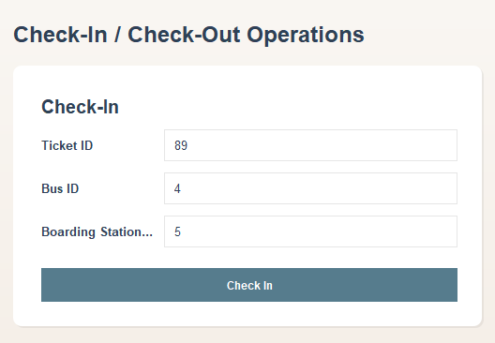
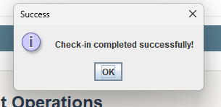
- invalid numeric input screenshot
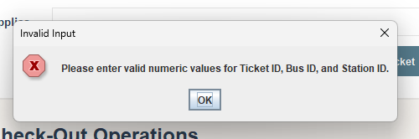

DB verification
For BB-CIN-01:
- verify ticket status changed from Active to Used

4.7 UC10 Check-Out
The report says checkout should only work for valid boarded tickets, update final status, log ride completion, and optionally prompt feedback. It also mentions scan-failure fallback.
Test ID | Technique | Scenario | Steps | Expected Result
BB-COUT-01 | Equivalence Partitioning | Valid check-out | Enter checked-in ticket ID and valid arrival station ID | Check-out succeeds
BB-COUT-02 | Error Guessing | Missing fields | Leave ticket or station blank | Validation error shown
BB-COUT-03 | Error Guessing | Non-numeric values | Enter invalid characters | Numeric validation error shown
BB-COUT-04 | Business Rule | Non-existent ticket | Use invalid ticket ID | Checkout fails
BB-COUT-05 | Business Rule | Ticket not checked in yet | Use active but not boarded ticket | Checkout rejected
BB-COUT-06 | Business Rule | Expired ticket | Use expired used ticket if reproducible | Checkout rejected
BB-COUT-07 | Business Rule | Already completed ride | Reuse already checked-out ticket | Checkout rejected

Evidence
- success popup
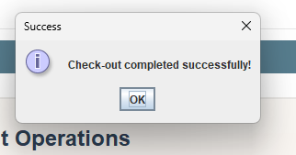
- failure popup for invalid checkout state
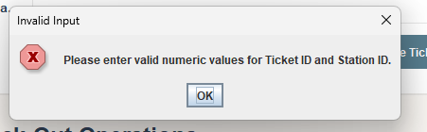

4.8 UC05 View Boarding Totals
The report says boarding totals are derived from check-ins minus check-outs and may be viewed per bus/trip/route/time window. It also notes that checked-in but not checked-out passengers remain onboard until completion.
Test ID | Technique | Scenario | Steps | Expected Result
BB-BRD-01 | Equivalence Partitioning | Daily totals view | Open Boarding Totals, choose Daily | Daily totals displayed
BB-BRD-04 | Business Rule | Total reflects check-ins minus check-outs | Prepare known ride data and view totals | Display matches expected onboard/aggregate counts
BB-BRD-05 | Negative | No data / empty result | Use date/domain with no data if possible | UI handles gracefully without crash

Evidence
- one screenshot for each time domain
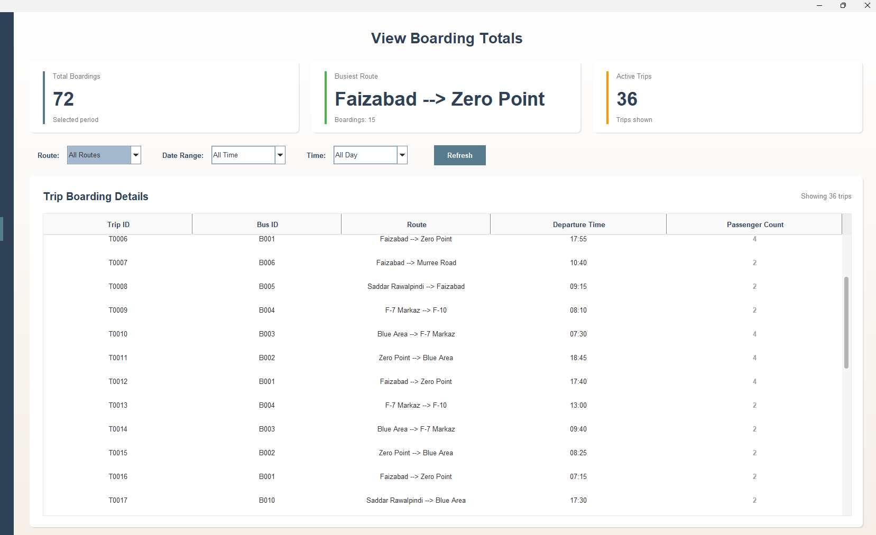
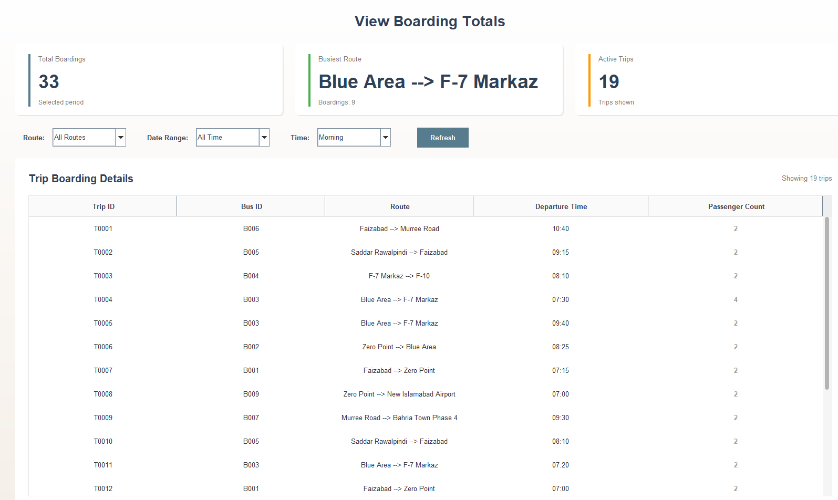
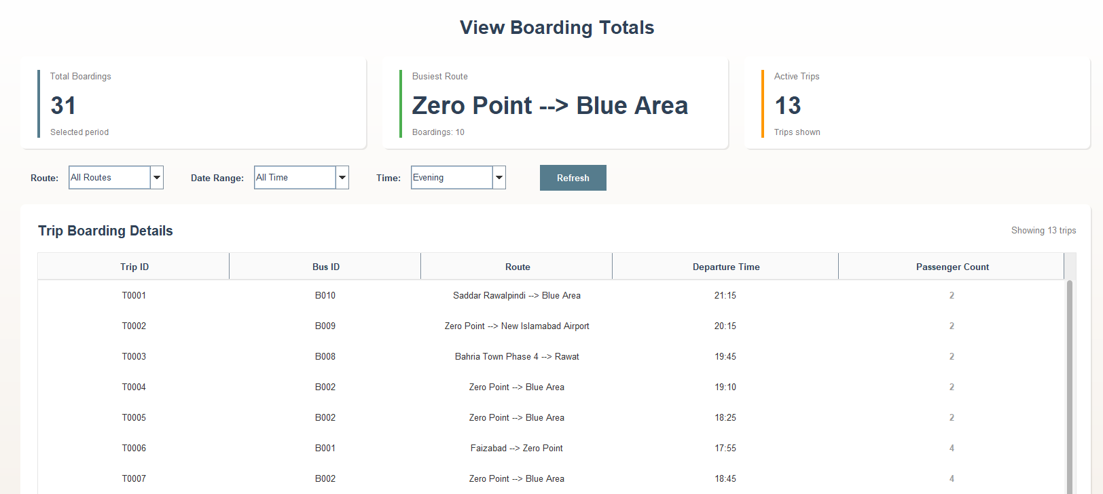
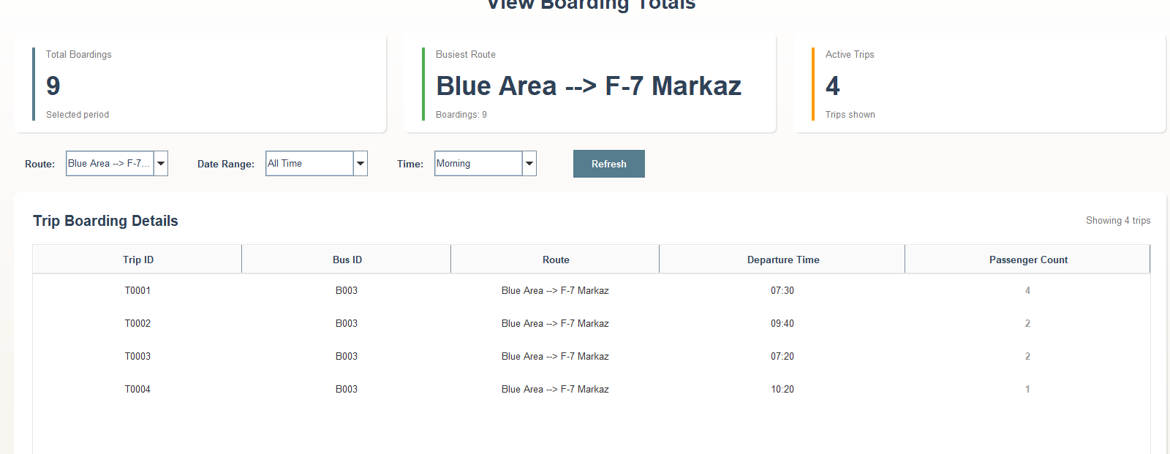
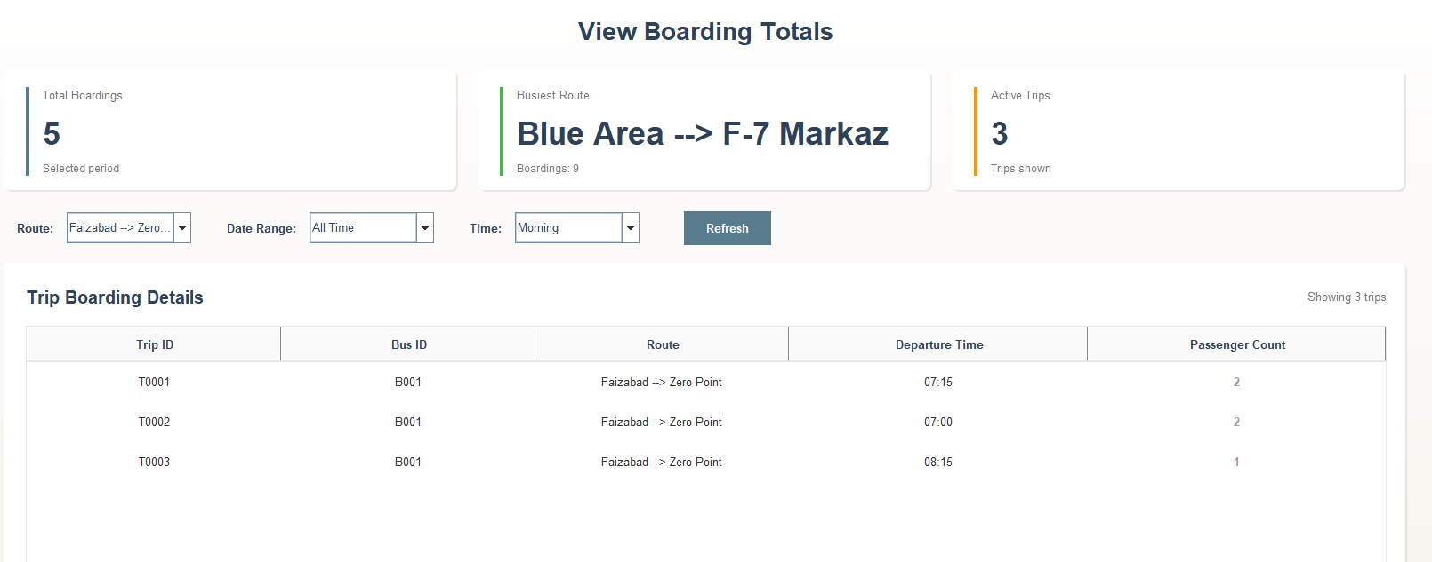
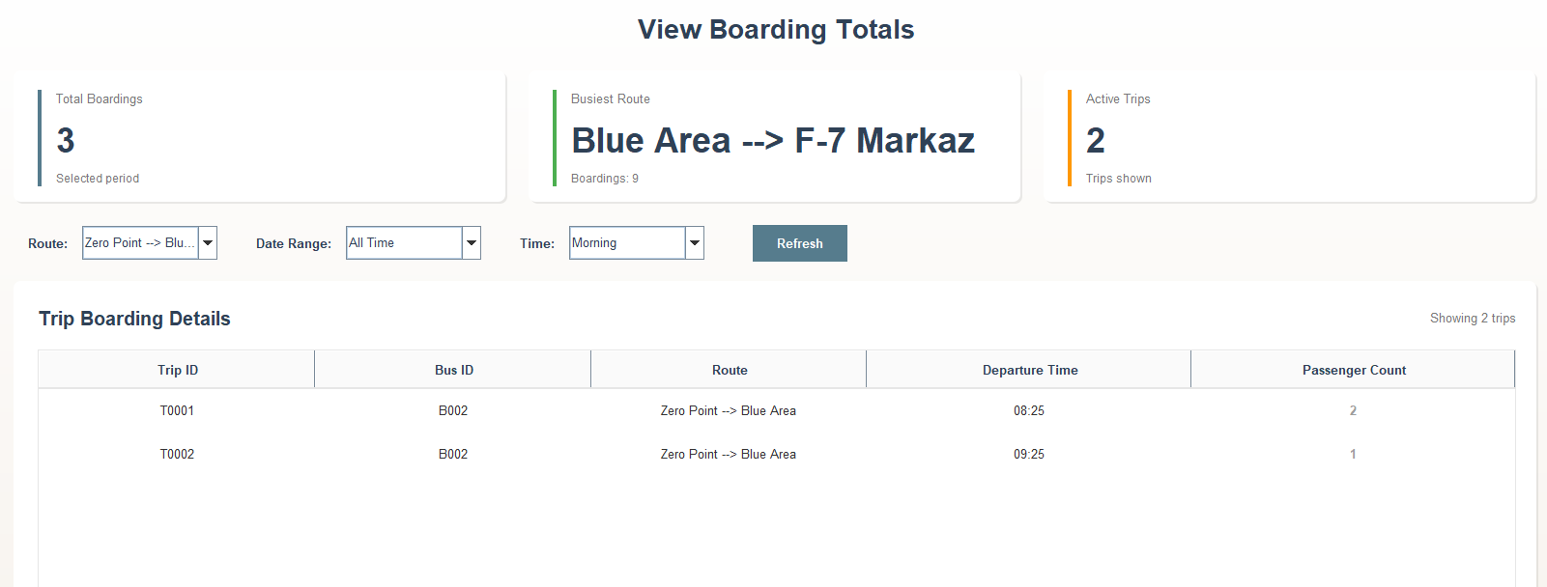

4.9 UC11 View Schedule
The report says schedule view should retrieve route schedules and show time/route/stop info, and return a “no schedule” condition when route data is unavailable.
Test ID | Technique | Scenario | Steps | Expected Result
BB-SCH-01 | Equivalence Partitioning | View schedule for route with active buses | Select valid route with active buses | Schedule displayed
BB-SCH-03 | Error Guessing | Invalid/missing route selection | Try loading schedule without a valid route | Graceful validation or no-crash behavior
BB-SCH-04 | Performance | Schedule load time | Load schedule for valid route | Response within acceptable range

Evidence
- schedule screen screenshot:
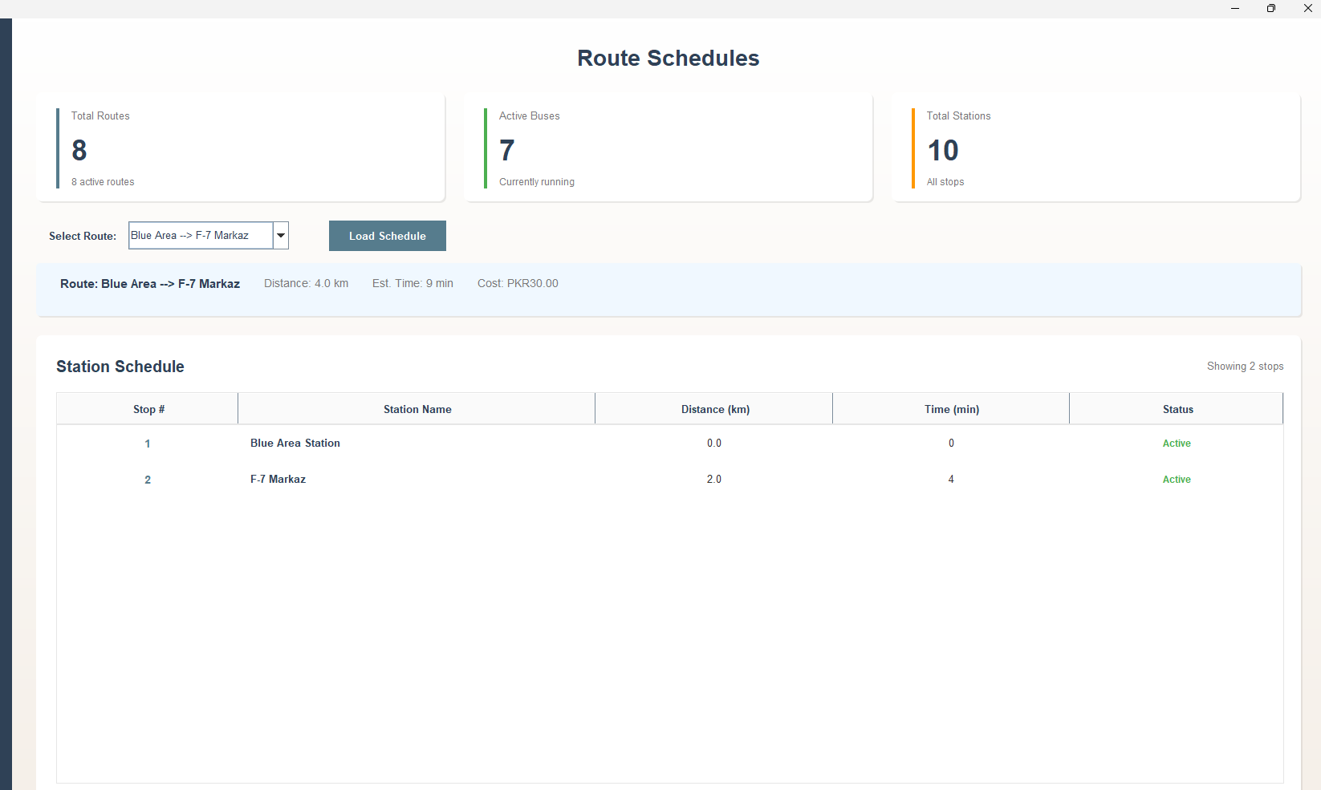
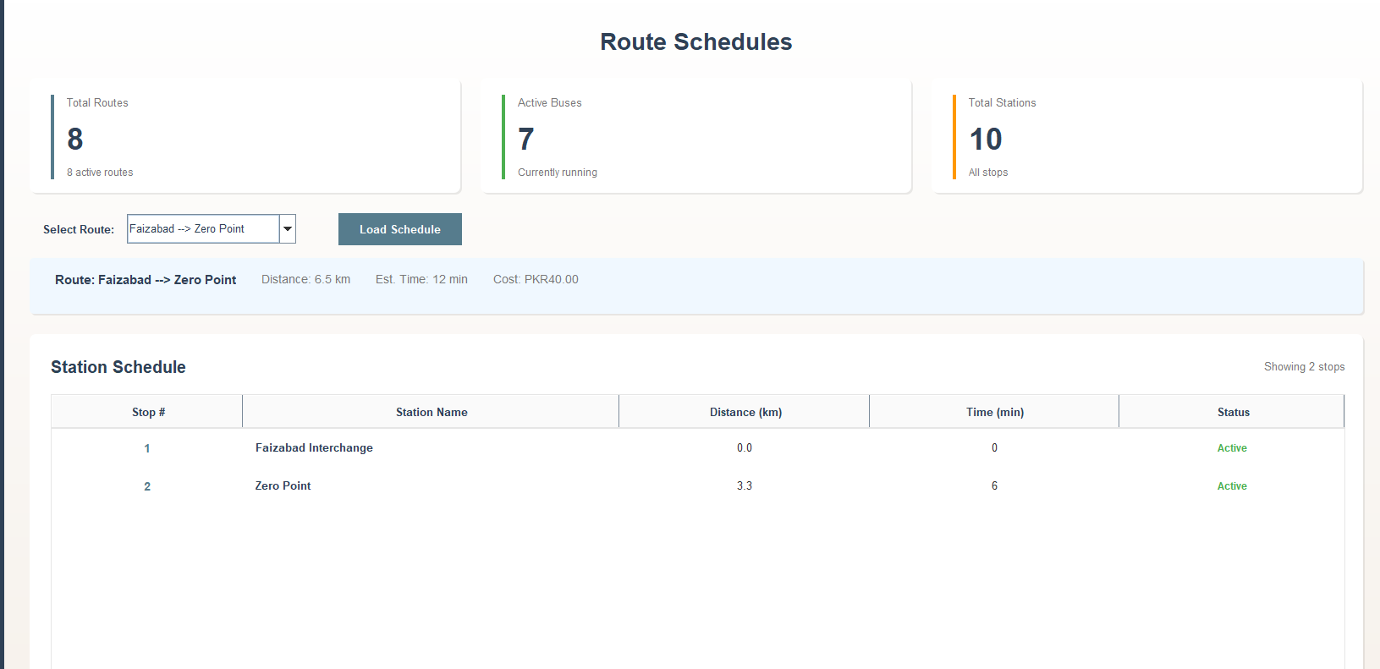

4.10 UC12 Check Balance
The report says balance should display the passenger’s current balance and handle missing passenger/unavailable service conditions.
Test ID | Technique | Scenario | Steps | Expected Result
BB-BAL-01 | Equivalence Partitioning | Valid passenger balance | Open balance for valid passenger | Correct balance shown
BB-BAL-02 | Error Guessing | Passenger not found | Query non-existent passenger | Appropriate error/invalid result shown
BB-BAL-03 | Business Rule | Balance after wallet ticket purchase | Check balance before and after wallet purchase | Reduced balance shown correctly

Evidence
- before/after balance screenshots:
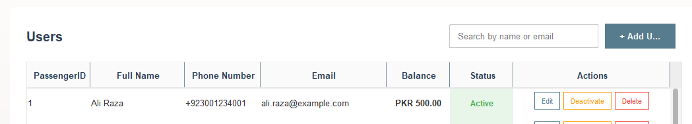
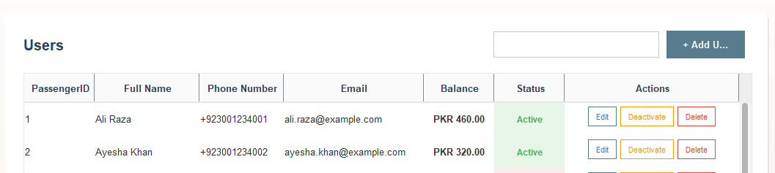

- DB verification screenshot for wallet balance field

4.11 UC13 View Peak Hours
The report says peak hours are retrieved from stored travel patterns and should display busiest time windows or an unavailable-data message.
Test ID | Technique | Scenario | Steps | Expected Result
BB-PEAK-01 | Equivalence Partitioning | Valid station peak-hour view | Open peak hours for a station with data | Peak-hour entries displayed
BB-PEAK-03 | Performance | Peak-hour retrieval speed | Load peak-hour analytics | Response within acceptable range

Evidence
- peak-hour chart/table screenshot
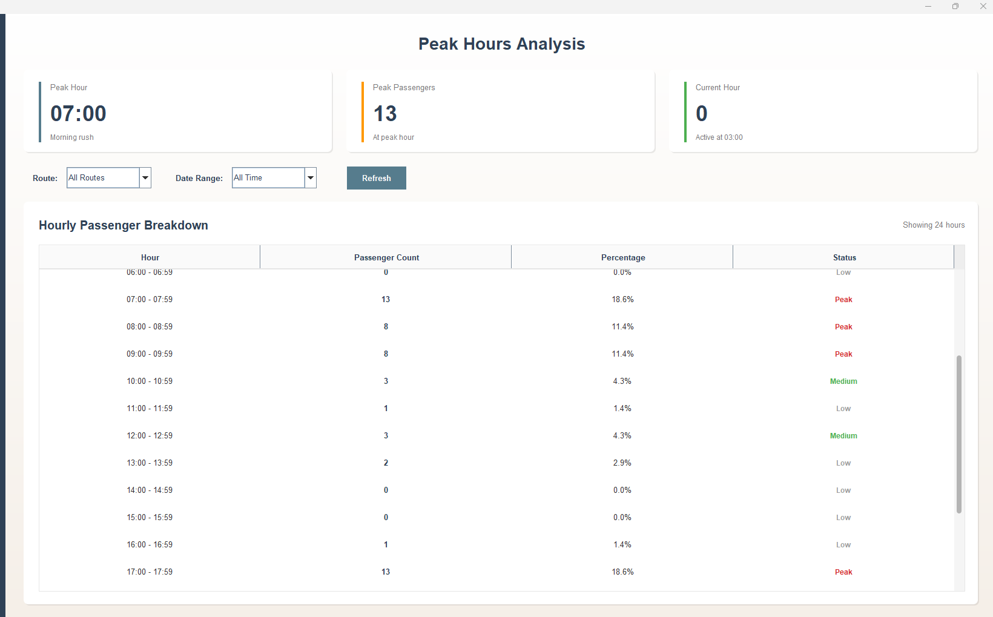

4.12 UC09 Submit Feedback
The report says feedback submission should store comments, reject blank feedback, reject invalid input, and confirm successful submission.
Test ID | Technique | Scenario | Steps | Expected Result
BB-FDB-01 | Equivalence Partitioning | Submit valid feedback | Enter valid feedback type and comments, then submit | Feedback stored successfully
BB-FDB-04 | DB Verification | Feedback persistence | Submit valid feedback, then verify record | Feedback row exists in DB

Evidence
- view feedback screen:
